Procedure for Norton’s Theorem: 1. Connections are given as per circuit diagram. 2. Set a particular value in RPS and note down the ammeter readings in the original circuit. To Find IN: 3. Remove the load resistance and short circuit the terminals. 4. For the same RPS voltage note down the ammeter readings. To Find RN: 5. Remove RPS and short circuit the terminal and remove the load and note down the resistance across the two terminals. Equivalent Circuit: 6. Set IN and RN and note down the ammeter readings. 7. Verify Norton’s theorem.
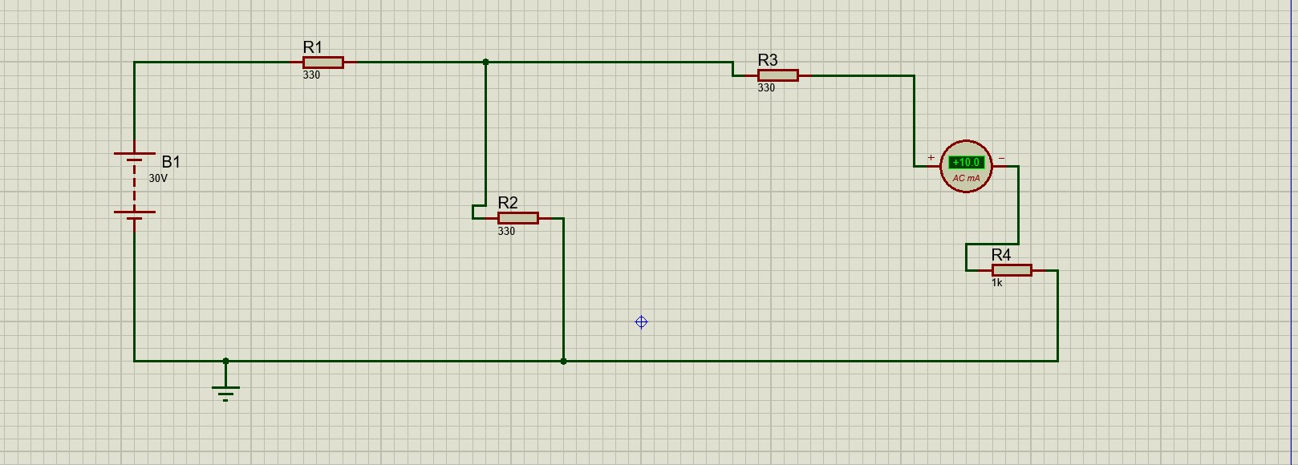

When we remove R4 and short the circuit IN:
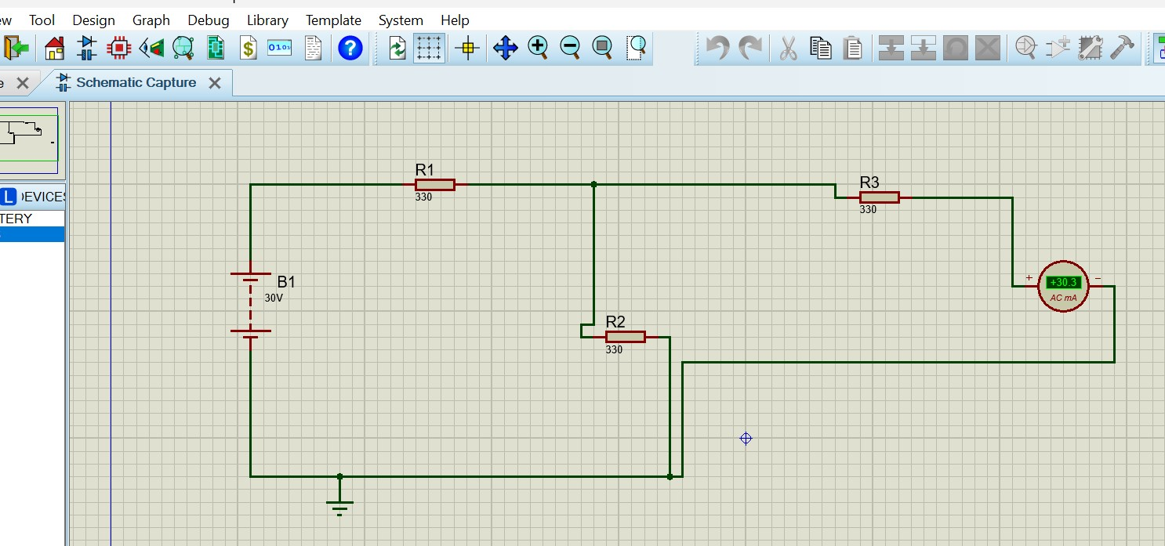

To Find RN:
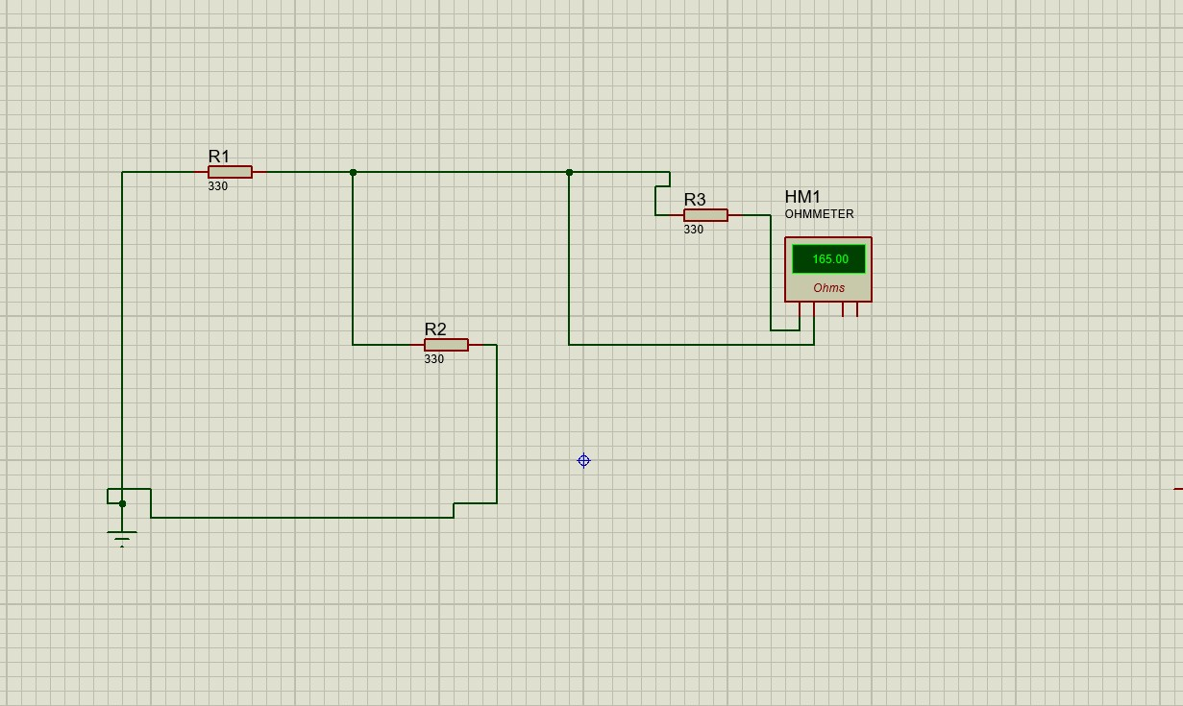

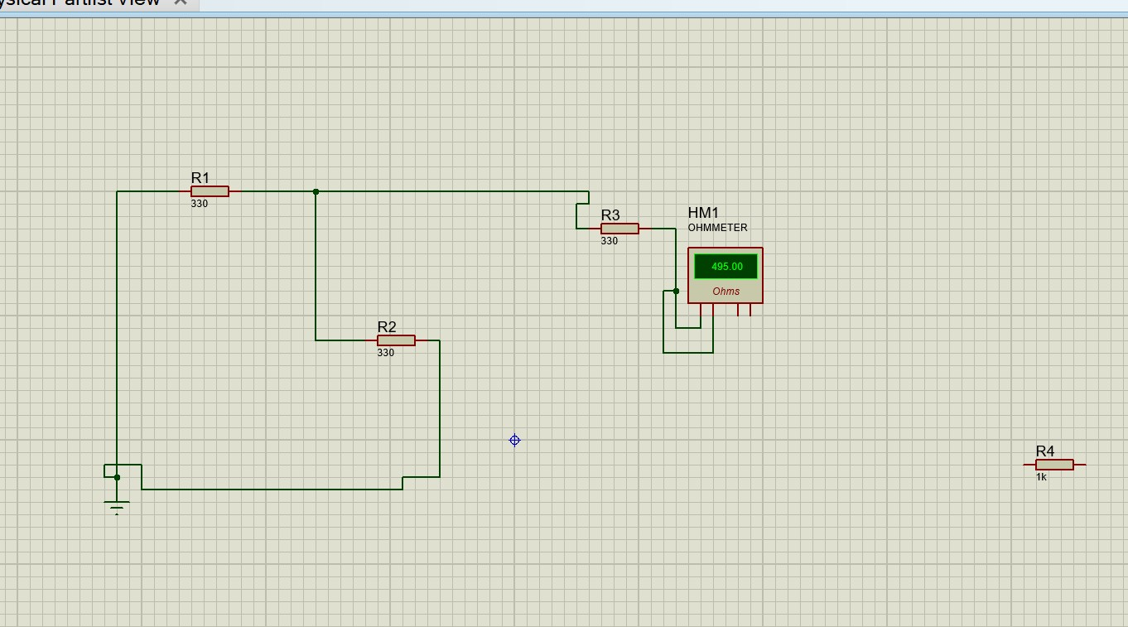

Equivalent Circuit:
